**Major Project On**

**Library Management System**

**Bachelor of Science**

Department of Mathematics Statistics & Data Science

By

**ANNAPU ANUSHA 110520539001**

**KAMBALA PARAMA SHIVA 110520539011**

**PADURLA PARTHY SURYA VAMSHI 110520539018**

**S RUSHENDRA 110520539020**

Under the guidance of

**S RAMBHOOPAL REDDY**

(Incharge Data Science)

Department of Data Science



**JAGRUTI DEGREE & PG COLLEGE**

PADMASHALI BHAVAN, NARAYANGUDA, HYDERABAD-500029



Padmashali Bhavan, Opp.to Blood Bank Lane, Narayanguda,

Hyderabad -500 029. Ph:040-24751670, 24751451, 24761554.

**CERTIFICATE**

This is to certify that the mini project entitled LIBRARY MANAGEMENT SYSTEM is submitted by ANNAPU ANUSHA (110520539001), KAMBALA PARAMA SHIVA (110520539011), PADURLA PARTHY SURYAVAMSHI (110520539018), S RUSHENDRA (110520539020) in partial fulfillment of the award of degree in BACHELOR’S DEGREE in Mathematics Statistics & Data Science during academic year 2022-2023

INTERNAL GUIDE PRINCIPAL

**S RAMBHOOPAL REDDY B. RAMKUMAR REDDY**

Department of Data Science

**DECLARATION**

We hereby declare that the industrial major project entitled “Library Management System using Python ” is the work done during the period from 20th February 2023 to 20th April 2023 and is submitted in the partial fulfillment of the requirements for the award of degree in Bachelor of Science from JAGRUTI DEGREE & PG COLLEGE Padmashali Bhavan, Narayanguda, Hyderabad-500029. The results embodied in this project have not been submitted to any other university or institution for the award of any degree or diploma.

BY

ANNAPU ANUSHA(110520539001)

KAMBALA PARAMA SHIVA(110520539011)

PADURLAPARTHY SURYA VAMSHI(110520539018)

S RUSHENDRA(110520539020)

**ACKNOWLEDGEMENT**

There are many people who helped us directly and indirectly to complete our project successfully. We would like to take this opportunity to thank one and all. First, we would like to express our deep gratitude towards our internal guide **S RAM BHOOPAL REDDY department of data science** for his support in the completion of our dissertation. And to our principal **B. RAMKUMAR REDDY** for providing the facilities to complete the dissertation. We would like to thank all our faculty and friends for their help and constructive criticism during the project period. Finally, we are very much indebted to our parents for their moral support and encouragement to achieve goals.

BY

ANNAPU ANUSHA(110520539001)

KAMBALA PARAMA SHIVA(110520539011)

PADURLAPARTHY SURYA VAMSHI(110520539018)

S RUSHENDRA(110520539020)

**ABSTRACT**

This project presents a Library Management System (LMS) designed to help librarians keep track of books, members, and loan transactions. The system is developed using Python programming language, with SQL database to store the data, and Tkinter library, the fastest and easiest ways to build GUI applications. Moreover, Tkinter is cross-platform, hence the same code works on macOS, Windows and Linux. The LMS allows librarians to add, view, update and delete books. Along with these it maintains the records of books issued to students with issued time and returned time phone number and address of student. LMS is user-friendly, easy to use, and provides an efficient way to manage a library's operations. The system is tested and evaluated to ensure its functionality and performance, and the results indicate that it is a reliable and efficient solution for library management. The LMS is expected to improve the productivity and efficiency of librarians and provide a better user experience for library members. The use of Python programming language in this project demonstrates its versatility and ability to handle complex data structures and operations. This project showcases the potential of Python in developing real-world applications. The purpose of a library management system is to streamline the processes involved in running a library. These processes include managing the library’s collection, tracking library materials, managing borrower accounts and handling transactions.

**CONTENTS Page No.**

Title Page………………………………………………………………………..1

Declaration………………………………………………………………………2

Certificate by Supervisor………………………………………………………..3

Acknowledgement………………………………………………………………4

Abstract…………………………………………………………………………5

1. **Chapter – 1**

**System Planning**

* 1. Project Aims and Objectives………………………………………………7
  2. Rationale…………………………………………………………………...8
  3. The system…………………………………………………………………9
  4. Modules………………………………………………………………10 - 18
  5. Role and Responsibilities………………………………………………….18
  6. Operation Environment…………………………………………………….19
  7. System Requirements………………………………………………………19

1. **Chapter – 2**

**Requirements & System Design**

* 1. Software Requirement Specification…………………………………21 - 22
  2. System Design………………………………………………………..22 - 39

1. **Chapter – 3**

**Discussions, Conclusions & References**

* 1. Discussions……………………………………………………………40 - 41
  2. Conclusions……………………………………………………………41 - 42
  3. References……………………………………………………………..42 - 43

**CHAPTER – 1**

**System Planning**

This chapter gives an overview about the aim, objectives, modules used to build and operation environment of the system.

1. **System Planning**

The developing process of Library Management System will be carried out in this chapter as well as the system objectives and scope.

* 1. **Project Aims and Objectives**

The project aims and objectives that will be achieves after completion of the system were carried out in this sub chapter. The succession of the system also will be evaluated through this sub chapter.

The project objectives are:

* To eliminate the paperwork in library.
* To record every transaction in computerized system so that problem such as file missing won’t happen again.
* To design a user-friendly Graphical User Interface (GUI) which suit the users.
* To complete the system according to project schedule.
  1. **Rationale**

Library Management System is an application refer to other library system and it is suitable to use by small and medium size library. It is used by librarian to manage the library using a computerized system. The system was developed and designed to help librarian record every book transaction so that such as file missing, or record missing will not happen again.

Book and member maintenance module also include in the Library Management System. User can register or edit the book in the system and record the transactions of the students with their address, mobile number. With this computerized maintenance, library will not loose the book record or member record which will always happen when no computerized system being used.

* 1. **The system**

A Library Management system is a software application used to manage the operations os a library. It includes features such as book cataloging and borrower management. A well-designed Library Management system can improve the efficiency and effectiveness of library operations, providing better service to library users.

Overview of Library Management System

* + 1. **Book Maintenance**

This feature has different operations as shown below

DELETE BOOK

UPDATE BOOK

VIEW BOOK

ADD BOOK

BOOK MAINTENANCE

**ADD BOOK :** The system will allow librarian to add new books to the library catalog.

**VIEW BOOK :** The system will allow librarian to view the books in the library catalog.

**UPDATE BOOK :** The system will allow librarian to update the details of the existing books in the library catalog.

**DELETE BOOK :** The system will allow librarian to delete books from library catalog.

* + 1. **Member Maintenance**

This feature has different operations as shown below

MEMBER MAINTENANACE

ISSUE BOOK

RETURN BOOK

**ISSUE BOOK :** The system will allow librarian to issue the book to student by taking the details like student phone number and address and the title of the book which is going to be issued and the system will also insert the date and time while issuing.

**RETURN BOOK :** The system will allow librarian to return book to library by selecting the previous record of the student from the list shown when the **return** button is tapped the book will get returned with the returned date and time while returning

* 1. **Modules**
     1. **TKINTER :** It is a Python library for creating graphical user interfaces (GUIs). It is a standard library, which means it is included with most Python installations, making it an accessible and popular choice for developers.

Tkinter is built on top of the Tcl/Tk GUI toolkit, which has been around since the 1990s. It provides a set of widgets, such as buttons, labels, and text boxes, that developers can use to create user interfaces. These widgets are highly customizable, allowing developers to control their appearance and behavior.

One of the benefits of using Tkinter is that it provides a simple and easy-to-use interface for building GUIs. It uses a system of event-driven programming, where user actions such as button clicks or key presses trigger events that can be handled by the code. This makes it easy to create interactive interfaces with minimal code.

Tkinter also provides a variety of layout managers, which help developers position widgets in their GUI. These layout managers, such as pack, grid, and place, allow developers to create complex and responsive interfaces that adjust to different screen sizes and user interactions.

Another benefit of using Tkinter is its cross-platform compatibility. Since Tkinter is built on top of the Tcl/Tk toolkit, which is written in C, it can run on a wide range of platforms, including Windows, macOS, and Linux.

In addition to the standard set of widgets and layout managers, Tkinter also supports a range of additional features. These include support for images and graphics, keyboard and mouse bindings, and the ability to create custom widgets.

While Tkinter provides many benefits, there are some limitations to consider. For example, the appearance of Tkinter widgets can be limited, making it difficult to create interfaces with a modern look and feel. Additionally, Tkinter can be slower than other GUI toolkits, particularly when dealing with complex interfaces or large amounts of data.

Overall, Tkinter is a powerful and accessible library for creating graphical user interfaces in Python. Its ease of use, cross-platform compatibility, and support for a range of features make it a popular choice for developers. While there are some limitations to consider, Tkinter remains a solid choice for creating GUIs in Python.

* + 1. **TREEVIEW :** Tkinter is a popular Python GUI toolkit that provides a set of standard GUI elements such as buttons, labels, and entry fields. One of the more complex GUI elements that Tkinter provides is the Treeview widget, which allows you to display hierarchical data in a structured and organized manner.

The Treeview widget is essentially a multi-column listbox that supports a tree-like structure. Each item in the tree can have one or more child items, and each item can contain one or more columns of data. The Treeview widget is especially useful for displaying data that has a parent-child relationship, such as a file system, a directory structure, or a database.

To create a Treeview widget in Tkinter, you first need to import the ttk module. The ttk module provides an advanced set of widgets that are not available in the standard Tkinter module.

Once you have created the Treeview widget, you can add columns to it using the "columns" attribute. Each column is defined by a unique identifier and a heading.

To add items to the Treeview widget, you use the insert() method. The insert() method takes several arguments, including the parent item, the index of the item, and the values for each column.

To display the Treeview widget, you can use the pack() or grid() method.

In summary, the Treeview widget in Tkinter provides a powerful and flexible way to display hierarchical data in a structured and organized manner. With the ability to add columns, parent items, and child items, you can easily create a Treeview widget that displays your data in an intuitive and easy-to-navigate way.

* + 1. **MESSAGEBOX :** Tkinter is a popular GUI toolkit for Python that provides several pre-defined dialogs, including messagebox, which provides a simple way to display pop-up message boxes to users. These message boxes can be used to display information, ask for confirmation, or prompt the user for input.

To use the messagebox in Tkinter, you first need to import it from the Tkinter library

Once you have imported the module, you can use one of the pre-defined functions to create a message box. There are several types of message boxes you can create, including:

showinfo(): displays a message box with an "OK" button and an information icon

showwarning(): displays a message box with an "OK" button and a warning icon

showerror(): displays a message box with an "OK" button and an error icon

askquestion(): displays a message box with "Yes" and "No" buttons and a question icon

askokcancel(): displays a message box with "OK" and "Cancel" buttons and a question icon

askyesno(): displays a message box with "Yes" and "No" buttons and a question icon

You can customize the message boxes by providing additional arguments to the functions, such as the parent window, the icon to display, and the button labels.

In summary, the messagebox module in Tkinter provides a convenient way to display pop-up message boxes to users, allowing you to display information, ask for confirmation, or prompt the user for input. With a variety of pre-defined functions and customizable options, you can easily create message boxes that meet your needs.

* + 1. **PILLOW :** The Pillow module is a powerful and popular Python library for working with images. It is a fork of the Python Imaging Library (PIL) and provides a wide range of image processing functionalities.

One of the primary uses of Pillow is to read and save images in various file formats such as JPEG, PNG, GIF, BMP, TIFF, and more. It provides a simple and easy-to-use interface for loading images from files and for saving images to files. This functionality is particularly useful when working with image datasets or when building image processing applications.

Pillow also provides a variety of image manipulation functionalities, such as resizing, cropping, and rotating images. These functionalities are useful when working with images of different sizes and aspect ratios, or when trying to extract specific portions of an image. In addition, Pillow provides image enhancement operations such as color balance, contrast adjustment, and brightness adjustment, which can be used to improve the visual quality of images.

Another powerful feature of Pillow is image filtering and manipulation using convolution matrices. Convolution matrices allow for the creation of various image filters, such as blurring, sharpening, and edge detection. These filters can be used to extract features from images or to enhance the visual quality of images.

Pillow also provides functionalities for text and shape drawing on images. This is useful when creating image annotations or when adding text or shapes to images for visualization purposes. Additionally, Pillow provides functionalities for image blending and compositing, which can be used to combine multiple images into a single image.

Pillow also allows for pixel-level access and manipulation of images. This is useful when working with images at a low level, such as when performing computer vision tasks or when creating custom image filters. Pillow provides an easy-to-use interface for accessing individual pixels in an image, and for manipulating the values of those pixels.

In addition to its core functionalities, Pillow also provides support for working with animated GIFs, which is useful when working with dynamic visual content. It also provides support for working with metadata in images, such as EXIF data, which can be used to extract information about the camera settings used to capture an image.

Pillow is widely used in the Python community for a variety of image processing tasks, such as image recognition, computer vision, and image filtering. Its simple and easy-to-use interface, combined with its powerful functionalities, make it an excellent choice for anyone working with images in Python.

* + 1. **SQLITE3 :** SQLite3 is a lightweight, self-contained relational database management system that is implemented as a library in the Python programming language. It provides a simple, fast, and reliable way to store and retrieve data in a structured manner.

To use SQLite3 in Python, you must first import the sqlite3 module. Once imported, you can create a connection to a SQLite database by calling the connect() function, passing in the name of the database file as an argument. If the database file does not exist, SQLite will create it for you automatically.

Once you have a connection to the database, you can execute SQL commands using a cursor object. The cursor is used to execute SQL commands and retrieve results. To execute a SQL command, you call the execute() method on the cursor object and pass in the SQL statement as a string.

To insert data into the table, you can use the execute() method with an INSERT statement. 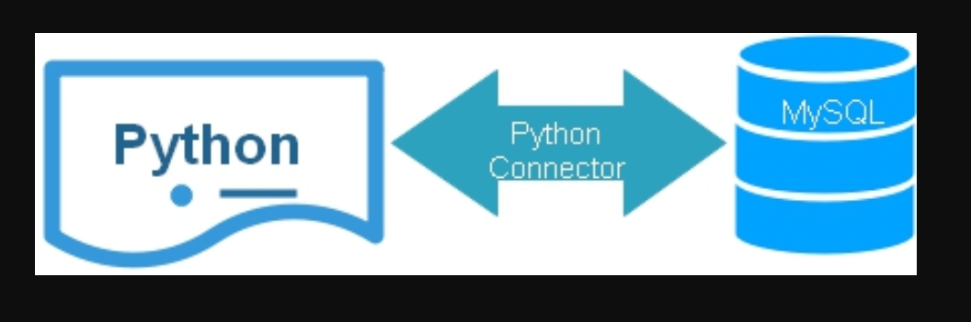

To retrieve data from the table, you can use the SELECT statement.

You can also use other SQL commands such as UPDATE and DELETE to modify data in the table.

Once you have finished working with the database, it is important to close the connection to the database using the close() method.

In summary, SQLite3 is a powerful and easy-to-use database management system that is built into Python. It provides a simple way to store and retrieve data in a structured manner and supports a wide range of SQL commands. SQLite3 is widely used in a variety of Python applications, from small desktop applications to large-scale web applications.

* + 1. **PYINSTALLER :** PyInstaller is a Python library used for converting a Python script into a standalone executable program. It is often used to package Python applications into an easy-to-distribute format, which can be executed without the need for a Python interpreter or other dependencies.

To use PyInstaller, you first need to install it on your system. You can install it using pip, the Python package installer

Once you have installed PyInstaller, you can use it to package your Python script into an executable file. To do this, you need to open a command prompt or terminal and navigate to the directory where your Python script is located.

This will create a directory called "dist" in the same directory as your Python script, which contains the executable file. The executable file can be run on any system that meets the requirements of your Python script, without requiring Python or any dependencies to be installed.

PyInstaller also supports many customization options, such as specifying the name of the executable file, including data files or other dependencies, and controlling the behavior of the packaged program. These options can be specified using command-line arguments or by creating a PyInstaller configuration file.

In addition to creating a standalone executable file, PyInstaller also provides support for building installer packages for various platforms, such as Windows, macOS, and Linux. These installer packages include the executable file, along with any necessary dependencies and other resources, and can be used to install the program on a user's system.

In summary, PyInstaller is a useful tool for packaging Python scripts into standalone executable programs, which can be easily distributed and executed without the need for a Python interpreter or other dependencies. With support for customization and building installer packages, PyInstaller is a versatile tool for creating Python applications that can run on any system.

|  |  |  |
| --- | --- | --- |
| ROLE | NAME | RESPONSIBILITIES |
| GUI developer and code debugging | S RUSHENDRA | * Creating windows * Entry boxes, Message boxes * Treeview |
| Buttons, functionalities and Background Image | ANNAPU ANUSHA | * Creating buttons * Button functionalities * Background image |
| Database Connection and operations | KAMBALA PARAMA SHIVA | * Connecting and closing database * CRUD operations |
| Testing, date time entry and app integration | PADURLA PARTHY SURYA VAMSHI | * Testing the system * Current time operation * Creating the application |

* 1. **ROLE AND RESPONSIBILITIES:**
  2. **OPERATION ENVIRONMENT**

|  |  |
| --- | --- |
| PROCESSOR | INTEL CORE I3 PROCESSOR |
| OPERATING SYSTEM | WINDOWS 8 |
| MEMORY | 4 GB RAM |
| HARD DISK SPACE | 512 GB HDD |
| DATABASE | Python’s SQLite3 |

* 1. **SYSTEM REQUIREMENTS**

|  |  |
| --- | --- |
| PROCESSOR | INTEL CORE I3 OR BETTER |
| OPERATIONG SYSTEM | WINDOWS 7, UBUNTU, LINUX |
| MEMORY | 2GB RAM |
| HARD DISK SPACE | 256 GB |

**CHAPTER-2**

**REQUIREMENTS**

**&**

**SYSTEM DESIGN**

In this chapter, we will discuss and analyze about the developing process of Library Management System including software requirement specification(SRS) and comparison between existing and proposed system. The functional and non-functional requirements are included in SRS part to provide complete description and overview of system requirements before the developing process is carried out. Besides that, existing vs proposed provides a view of how the proposed system will be more efficient than the existing one.

* 1. **SOFTWARE REQUIREMENT SPECIFICATION**
     1. **GENERAL DESCRIPTION**

PRODUCT DESCRIPTION :

Library Management System is a computerized system which helps librarian to manage the library daily activity in electronic format. It reduces the risk of paperwork such as file lost, file damaged and time consuming. It can help librarian to manage the transaction or record more effectively and timesaving.

PROBLEM STATEMENT :

* File lost

When computerized system is not implemented file is always lost because of human environment. Sometimes due to human error there may be loss of records.

* File damaged

When a computerized system is not there file is always lost due to some accident like spilling of water by someone on file accidentally. Besides some natural disaster like floods or fires may also damage the files.

* Space consuming

After number of records become large the space for physical storge of file and records also increases if no computerized system is implemented.

* Cost consuming

As there is no computerized system to add each paper will be needed which will increase the cost for the management of library.

* + 1. **SYSTEM OBJECTIVES**
* Improvement in control and performance.

The system is developed to cope up with the current issues and problems of library.

* Save cost

After computerized system is implemented less human force will be required to maintain the library thus reducing the overall cost.

* 1. **SYSTEM DESIGN**
     1. **USER INTERFACE**

To open Library Management System first you need to open “Library_Management_System.exe” file.

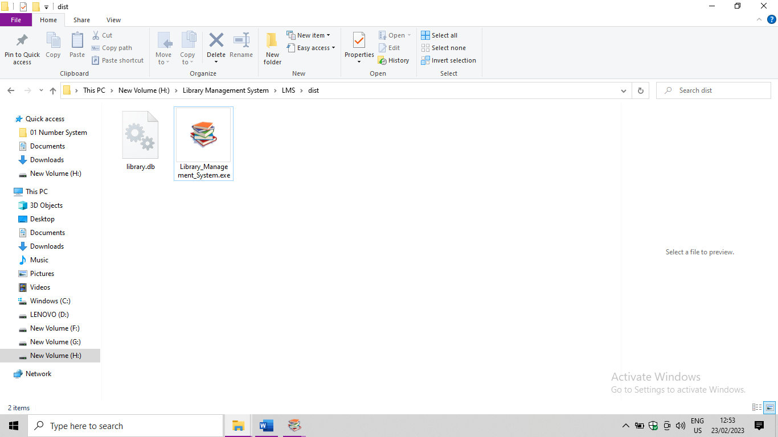

You can see the user interface as shown in figure below.

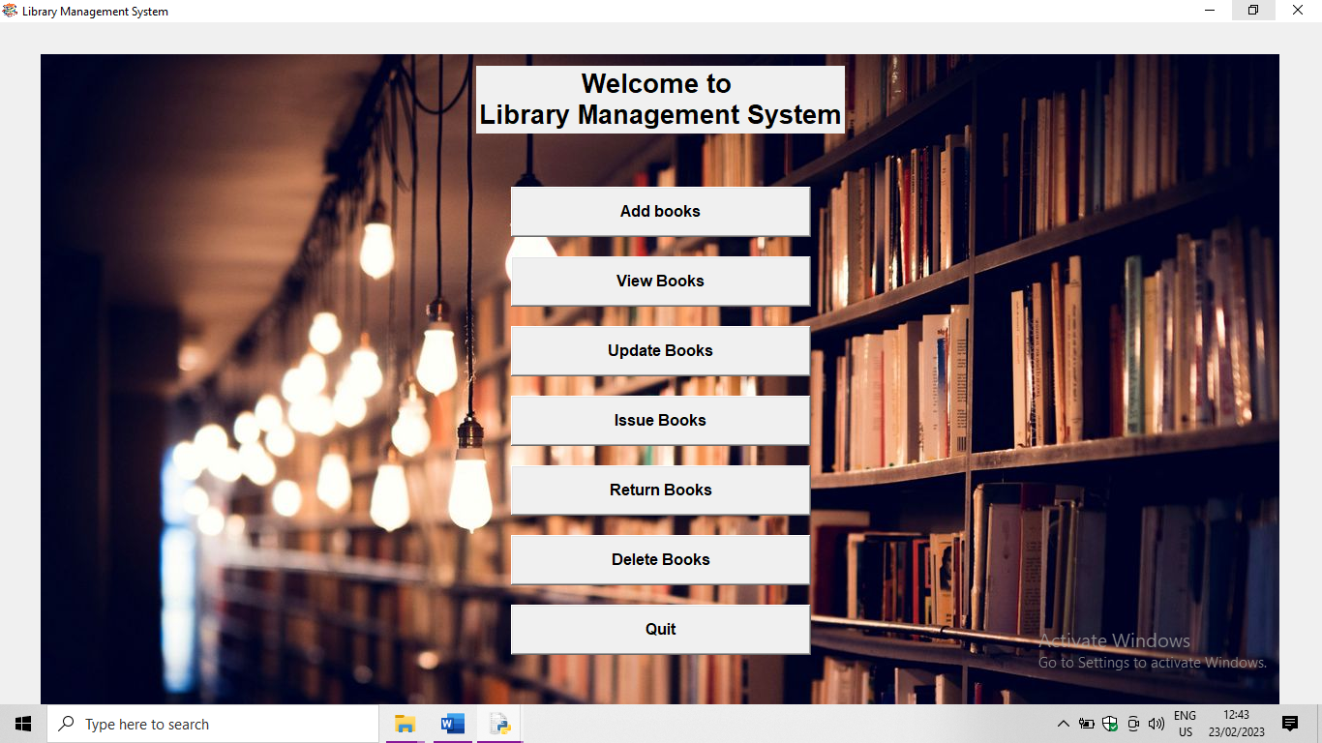

You can see the following buttons in the user interface.

* Add Books
* View Books
* Update Books
* Issue Books
* Return Books
* Delete books
* Quit
  + 1. **Add Books :**

When “Add Books” button is clicked new top window name “Adding a book to library” pops up and asks the following details

* Book ID (ISBN No. of the book)
* Book Title
* Author

as shown in figure below.

* + - 1. Background Functionality:

When the “Add books” button is clicked the application will create a new database named “library.db” if not exists and when the above-mentioned details are given, “books” table is created in the database and when “Submit” button is clicked those details get created in the database and connection of database closes. When cancel button is clicked it clears the input given by the user and aborts the operation.

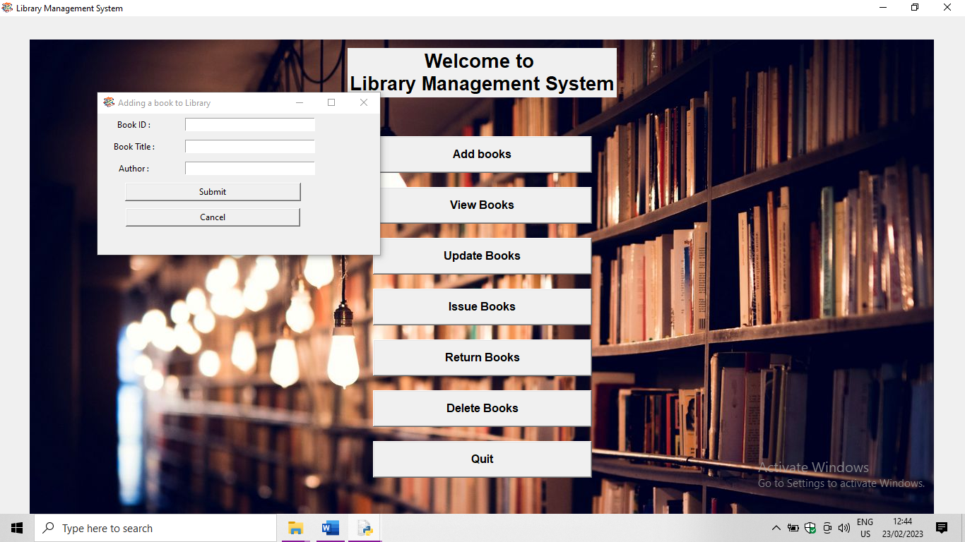

* + 1. **View Books :**

When “View Books” button is clicked new top window named “Viewing books in library” pops up and shows the details of the books such as

* serial number (This should be remembered by the user if he/she wants to make changes to the book details or delete them)
* Book ID
* Title and
* Author

as shown in figure below.

2.2.3.1 Background Functionality:

When “View books” button is clicked, this gets connected to the “library.db” database and retrieve the information present in the “books” table in the database and closes the database connection.

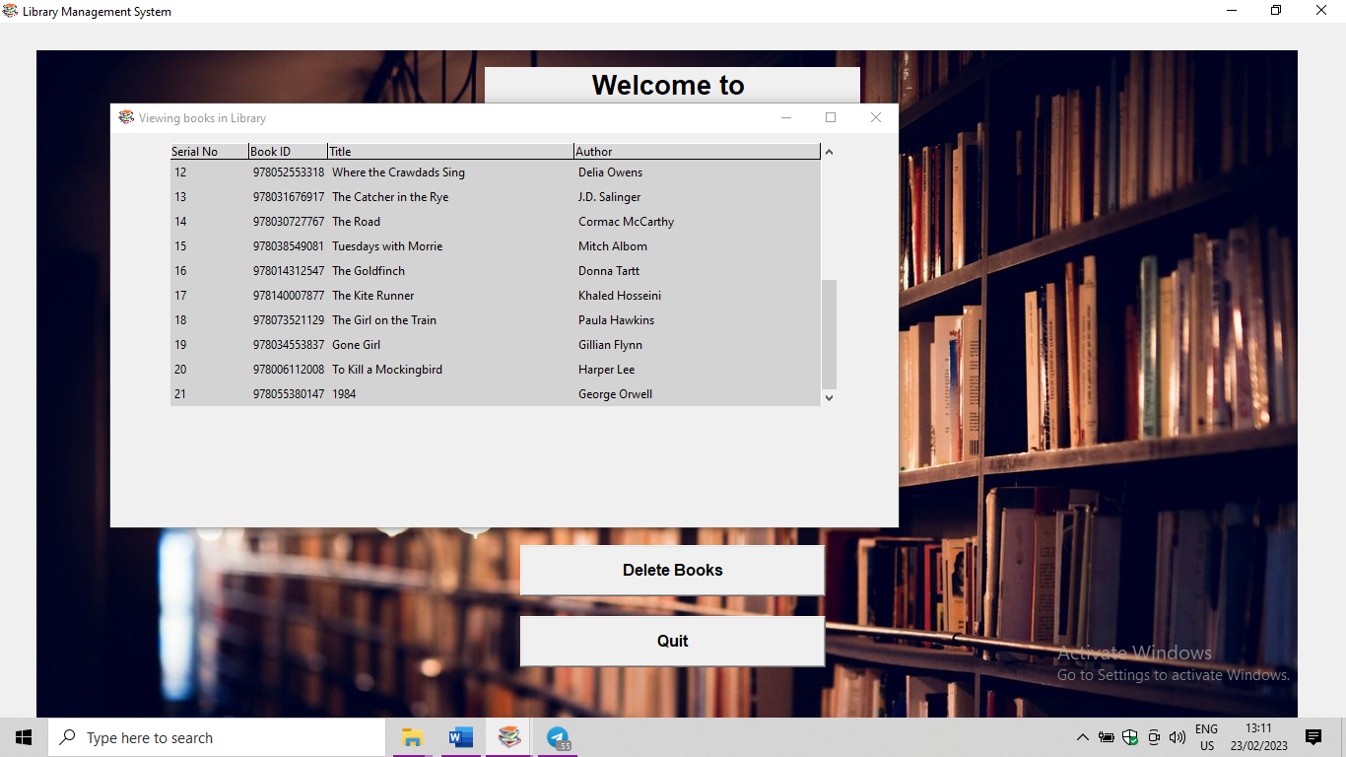

* + 1. **Update Books :**

When “Update Books” button is clicked new top window named “Updating a book” pops up and asks for

* Serial No. (For which he/she wants to update the details)
* Book ID
* Book Title and
* Author

as shown in figure below.

* + - 1. Background Functionality:

When “Update books” button is clicked, this gets connected to the “library.db” database and updates the details of Book ID, Book Title and Author in the “books” table and closes the connection of database when “Submit” button is clicked. We can see the changes by clicking on “View Books”. When “Cancel” button is clicked the (if any) details given before will get erased and no changes will take place to the details of the book.

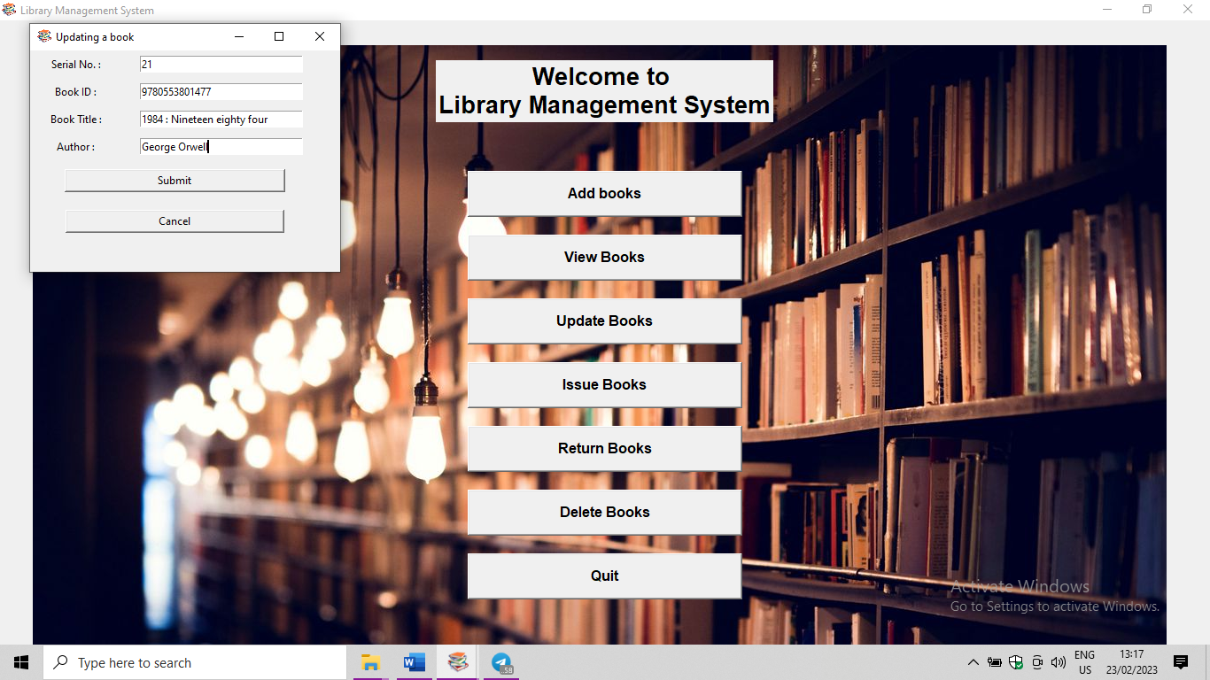

* + 1. **Issue Books :**

When “Issue Books” button is clicked a new top-level window named “Issuing book to student” pops up and ask user to enter the following details.

* Title of book
* Student Name
* Phone and
* Address

as shown below

* + - 1. Background Functionality:

When “Issue Books” button is clicked, this gets connected to “library.db” database and creates a table named “books_issued” if not exists and the details entered will be inserted into the table with the current date and time connection will be closed after the insertion is completed when the “Submit” button is clicked. This operation aborts if “Cancel” button is clicked.

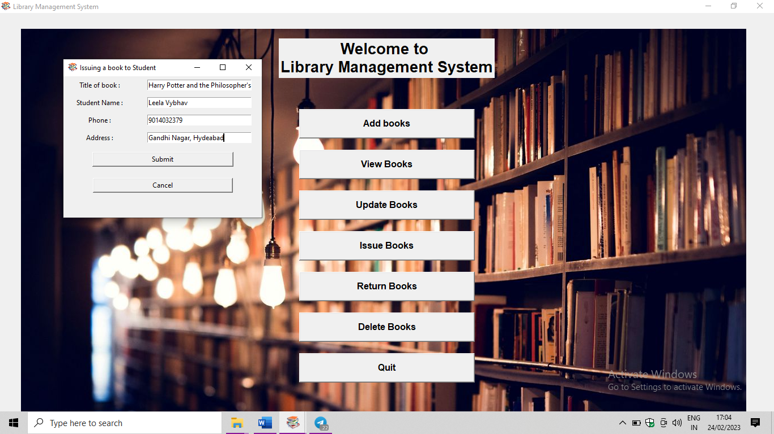

* + 1. **Return Books:**

When “Return Books” button is clicked a new top-level window named “Returning book to library” pops up and shows all the issued books with Serial No., Title of the book, Student Name, Issued Date, Return Date, Phone and Address with return date as “None” if book is not returned to library to return book select which book and which student is returning the book the serial number of that record will be shown in the entry box below under “Selected Record & Commands” tab. When

“Return” button is clicked the returned date and time gets updated as shown below.

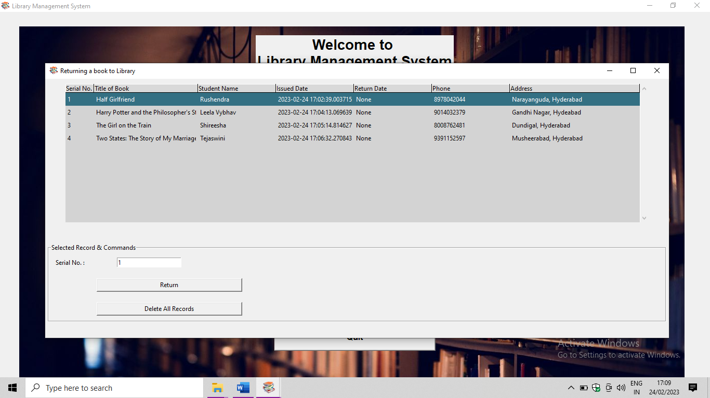

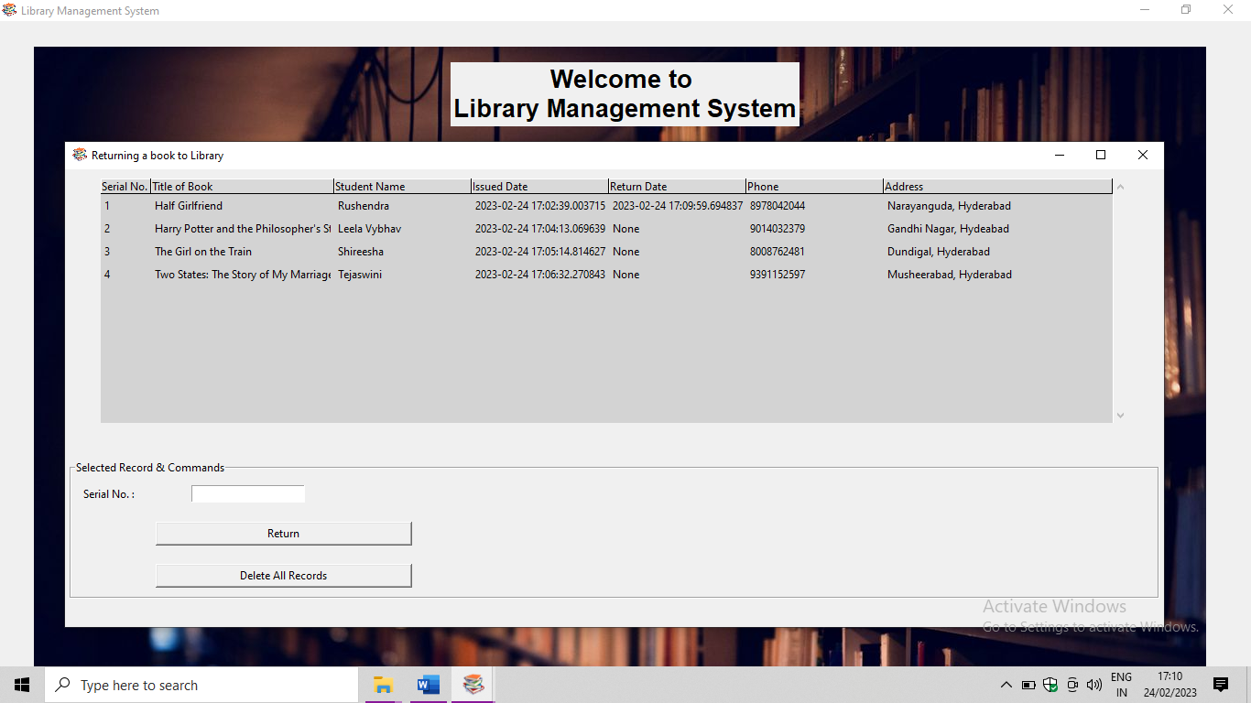

If he/she wants to delete all the records from the database “Delete All Records” button should be clicked. A message box is shown “Are you sure?” showing the message as shown in below. If user confirms by clicking “Yes” all the records gets deleted if not operation gets aborted.

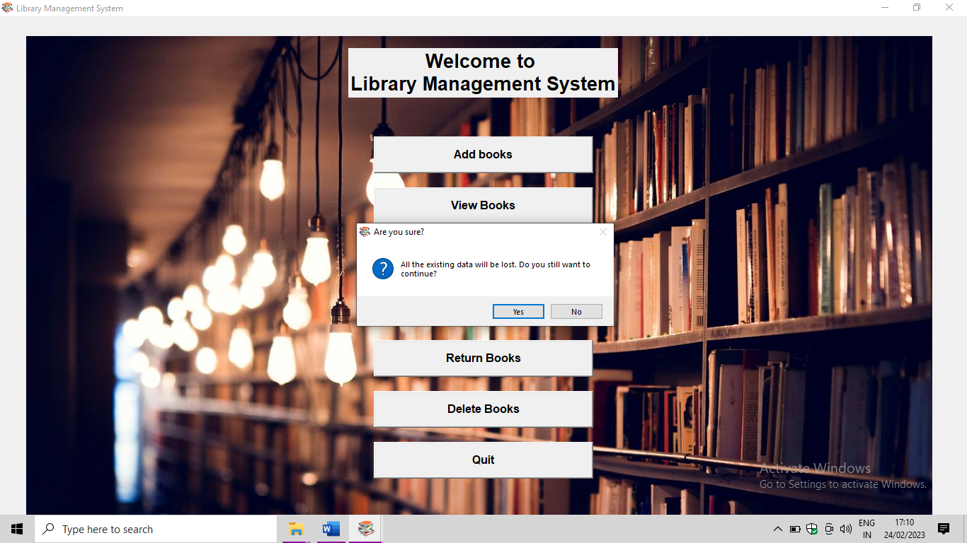

* + - 1. Background Functionality:

When “Return Books” button is clicked the data is retrieved from “books_issued” table from “library.db” database and the records will be shown in the top-level window after selecting a record the serial number will be shown below when “Return” button is clicked the date and time in Return Date column will be updated with current date and time.

If “Delete All Records” button is clicked and confirmed with “Yes” the “books_issued” table is dropped.

* + 1. **Delete Books:**

When “Delete Books” button is clicked a new top-level window named “Deleting book from library” pops up and asks for the Serial No. as shown in figure below.

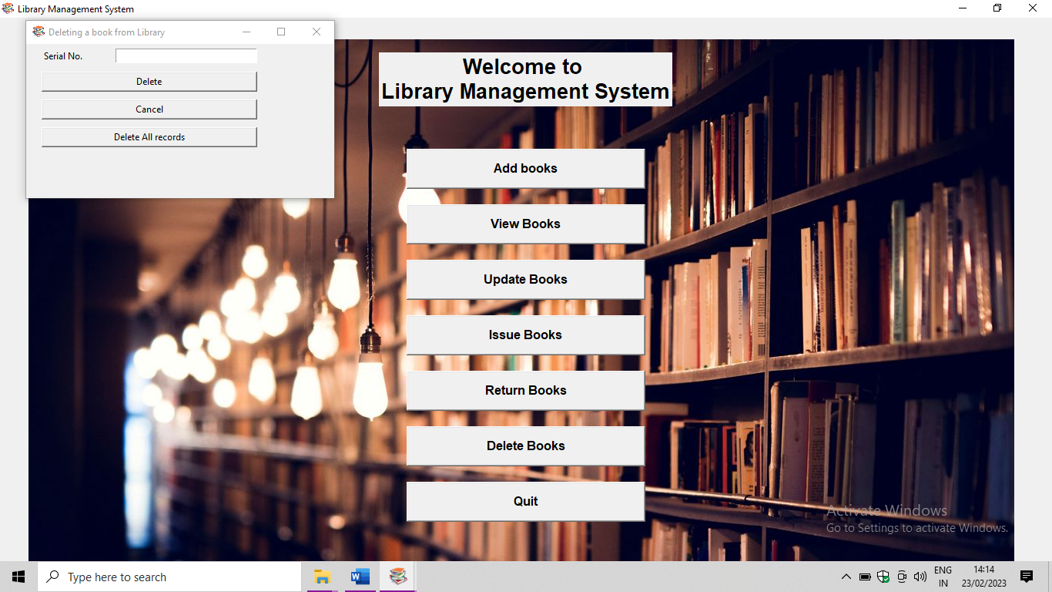

when serial number is given and “Delete” button is clicked the book gets deleted and the entry box will be cleared. If “Cancel” button is clicked the entry box will be cleared and the operation gets aborted.

If he/she wants to delete all records from library “Delete All Records” button is clicked a message box “Are you sure?” appears and If it’s confirmed with “Yes” button all the books in the library gets deleted. If not “No” button is clicked the operation gets aborted.

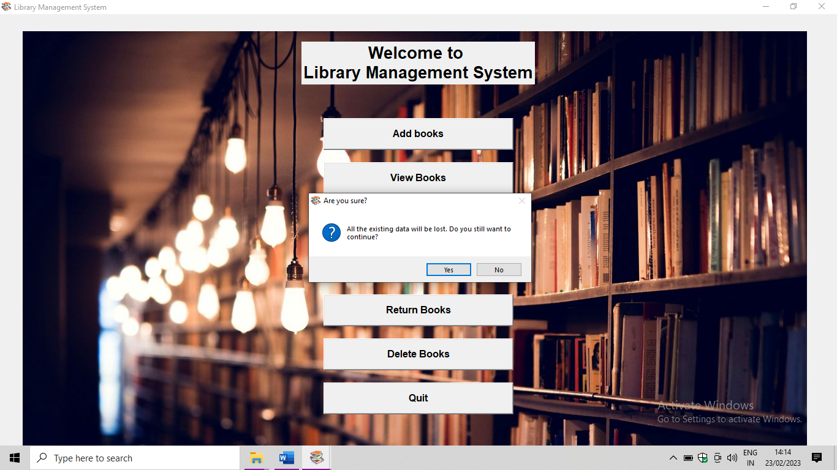

* + - 1. Background Functionality:

When “Delete” button is clicked the record with the serial no. mentioned will be deleted from “books” table from “library.db” database. If “Delete All Records” button is clicked and confirmed with “Yes” button the “books” table is dropped. From “library.db” database.

* + 1. **Quit:**

When “Quit” button is clicked the main window (i.e., Library Management System) along with all the opened top-level windows will be closed.

**CHAPTER – 3**

**DISCUSSIONS, CONCLUSIONS**

**&**

**REFERENCES**

* 1. **DISCUSIONS:**

A library management system using Python Tkinter and SQL module can be a robust and efficient solution for managing a library's operations. Here are some discussions on the different aspects of this system:

* Graphical User Interface (GUI): Python Tkinter is an excellent choice for creating a graphical user interface for the library management system. It provides a variety of widgets and tools for designing an interactive and user-friendly interface. The GUI can display data from the database, and users can add, edit, and delete records with ease.
* Database management: SQL module provides a powerful interface for managing the library's database. It can be used to create tables to store book and borrower data, manage transactions, and generate reports. SQL can also be used to implement features such as search, sort, and filter functions, making it easy for librarians to find specific books or borrowers quickly.
* Reports and analytics: A library management system can generate various reports and analytics to provide insights into the library's operations. Reports can include data on the number of books issued, the most popular books, and the most frequent borrowers, among others. Such reports can help librarians make data-driven decisions and improve the library's operations.
* Scalability: As the library grows, the system should be designed to accommodate an increasing number of books, borrowers, and transactions. The system should be scalable, allowing librarians to add more records and functionalities as needed.
  1. **CONCLUSIONS:**

A library management system using Python Tkinter and SQLite3 module can be a great tool for managing books, borrowers, and other related data in a library. The application can allow librarians to add, edit, and delete books and borrower records, as well as manage transactions and generate reports.

Python Tkinter can be used to create a graphical user interface for the application, while the SQLite3 module can be used to manage the database backend. With the help of these tools, the application can offer a user-friendly and efficient way to manage a library's resources and operations.

Overall, the library management system developed using Python Tkinter and SQLite3 module can provide a powerful and flexible solution for managing a library's daily operations and can contribute to improving the efficiency and quality of services provided to library patrons.

* 1. **REFERENCES:**

1. "Python GUI Programming Cookbook" by Burkhard A. Meier - This book provides practical recipes for building modern GUIs using Python Tkinter and covers topics like creating windows, dialogs, buttons, and text labels.
2. "Python and Tkinter Programming" by John Grayson - This book is a comprehensive guide to building GUI applications using Python and Tkinter, and includes coverage of advanced topics like event handling, animation, and custom widgets.
3. Python Tkinter Documentation - The official Python Tkinter documentation provides a comprehensive guide to creating GUI applications using Tkinter, including information on events, widgets, and geometry management. You can find it here: <https://docs.python.org/3/library/tkinter.html>
4. "Python GUI Programming with Tkinter" by Alan D. Moore
5. "Tkinter GUI Application Development Blueprints" by Bhaskar Chaudhary
6. "Python and Tkinter Programming" by John E Grayson
7. "Tkinter GUI Application Development Projects" by Bhaskar Chaudhary
8. "Python GUI Programming Cookbook" by Burkhard A. Meier
9. "Tkinter GUI Application Development HOTSHOT" by Rohit V. Chavan
10. "Python Tkinter for Beginners" by Peter Fisher
11. "Tkinter GUI Programming by Example" by David Love
12. "Python GUI Programming: A Complete Reference Guide" by Alan D. Moore
13. "Tkinter GUI Application Development" by Jennifer Roseburg.